**1. Write a program to check if a number is positive, negative, or zero.**

**#include <stdio.h>**

**void main()**

**{**

**int num;**

**printf("Enter a number: ");**

**scanf("%d", &num);**

**if (num > 0)**

**printf("Positive\n");**

**else if (num < 0)**

**printf("Negative\n");**

**else**

**printf("Zero\n");**

**return ;**

**}**

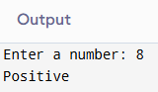

**2.** **Write a program to find the largest among three numbers.**

**#include <stdio.h>**

**void main()**

**{**

**int a, b, c;**

**printf("Enter three numbers: ");**

**scanf("%d%d%d", &a, &b, &c);**

**if (a >= b && a >= c)**

**printf("Largest is %d\n", a);**

**else if (b >= a && b >= c)**

**printf("Largest is %d\n", b);**

**else**

**printf("Largest is %d\n", c);**

**return ;**

**}**

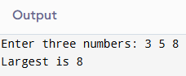

**3.** **Write a program to check if a year is a leap year.**

**#include <stdio.h>**

**void main()**

**{**

**int year;**

**printf("Enter a year: ");**

**scanf("%d", &year);**

**if ((year % 4 == 0 && year % 100 != 0) || (year % 400 == 0))**

**printf("Leap year\n");**

**else**

**printf("Not a leap year\n");**

**return ;**

**}**

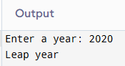

**4.** **Write a program to check whether a character is a vowel or consonant.**

**#include <stdio.h>**

**void main()**

**{**

**char ch;**

**printf("Enter a character: ");**

**scanf(" %c", &ch);**

**if ((ch >= 'a' && ch <= 'z') || (ch >= 'A' && ch <= 'Z')) {**

**if (ch == 'a' || ch == 'e' || ch == 'i' || ch == 'o' || ch == 'u' ||**

**ch == 'A' || ch == 'E' || ch == 'I' || ch == 'O' || ch == 'U')**

**printf("Vowel\n");**

**else**

**printf("Consonant\n");**

**} else {**

**printf("Not an alphabet\n");**

**}**

**return ;**

**}**

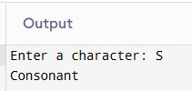

**5.** **Write a program to assign grades based on marks.**

**#include <stdio.h>**

**void main()**

**{**

**int marks;**

**printf("Enter marks (0-100): ");**

**scanf("%d", &marks);**

**if (marks >= 90)**

**printf("Grade A\n");**

**else if (marks >= 75)**

**printf("Grade B\n");**

**else if (marks >= 60)**

**printf("Grade C\n");**

**else if (marks >= 40)**

**printf("Grade D\n");**

**else**

**printf("Fail\n");**

**return ;**

**}**

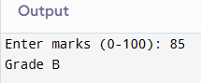

**6.** **Write a program to check whether a number is divisible by 5 and 11.**

**#include <stdio.h>**

**void main()**

**{**

**int num;**

**printf("Enter a number: ");**

**scanf("%d", &num);**

**if (num % 5 == 0 && num % 11 == 0)**

**printf("Divisible by both 5 and 11\n");**

**else**

**printf("Not divisible by both 5 and 11\n");**

**return ;**

**}**

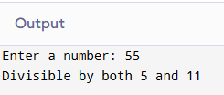

**7.** **Write a program to find the absolute value of a number.**

**#include <stdio.h>**

**void main()**

**{**

**int num;**

**printf("Enter a number: ");**

**scanf("%d", &num);**

**if (num < 0)**

**num = -num;**

**printf("Absolute value: %d\n", num);**

**return ;**

**}**

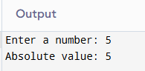

**8.** **Write a menu-driven program to perform +, -, *, / operations.**

**#include <stdio.h>**

**void main()**

**{**

**int a, b, choice;**

**printf("Enter two numbers: ");**

**scanf("%d%d", &a, &b);**

**printf("Menu:\n1.Add\n2.Subtract\n3.Multiply\n4.Divide\nEnter choice: ");**

**scanf("%d", &choice);**

**switch (choice) {**

**case 1:**

**printf("Result: %d\n", a + b);**

**break;**

**case 2:**

**printf("Result: %d\n", a - b);**

**break;**

**case 3:**

**printf("Result: %d\n", a * b);**

**break;**

**case 4:**

**if (b != 0)**

**printf("Result: %.2f\n", (float)a / b);**

**else**

**printf("Division by zero error\n");**

**break;**

**default:**

**printf("Invalid choice\n");**

**}**

**return ;**

**}**

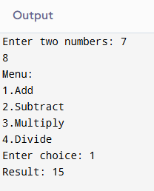

**9.** **Write a program to find roots of a quadratic equation.**

**#include <stdio.h>**

**#include <math.h>**

**void main()**

**{**

**float a, b, c, discriminant, root1, root2;**

**printf("Enter coefficients a, b, c: ");**

**scanf("%f%f%f", &a, &b, &c);**

**discriminant = b*b - 4*a*c;**

**if (discriminant > 0) {**

**root1 = (-b + sqrt(discriminant)) / (2*a);**

**root2 = (-b - sqrt(discriminant)) / (2*a);**

**printf("Roots are real and different: %.2f, %.2f\n", root1, root2);**

**} else if (discriminant == 0) {**

**root1 = -b / (2*a);**

**printf("Roots are real and same: %.2f\n", root1);**

**} else {**

**float real = -b / (2*a);**

**float imag = sqrt(-discriminant) / (2*a);**

**printf("Roots are complex: %.2f + %.2fi, %.2f - %.2fi\n", real, imag, real, imag);**

**}**

**return ;**

**}**

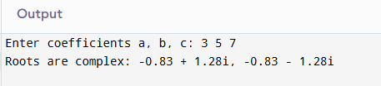

**10.** **Write a program to find the number of digits in a number.**

**#include <stdio.h>**

**void main()**

**{**

**int num, count = 0;**

**printf("Enter a number: ");**

**scanf("%d", &num);**

**if (num == 0)**

**count = 1;**

**else {**

**while (num != 0) {**

**num /= 10;**

**count++;**

**}**

**}**

**printf("Number of digits: %d\n", count);**

**return ;**

**}**

